**Name : Hardik Bhoir_JH**

**ASSIGNMENT NO 01**

1. **Hello World Program**: Write a Java program that prints "Hello World!!" to the console

class Program{

public static void main(String args[]){

System.out.println("heloooo world");

}

}

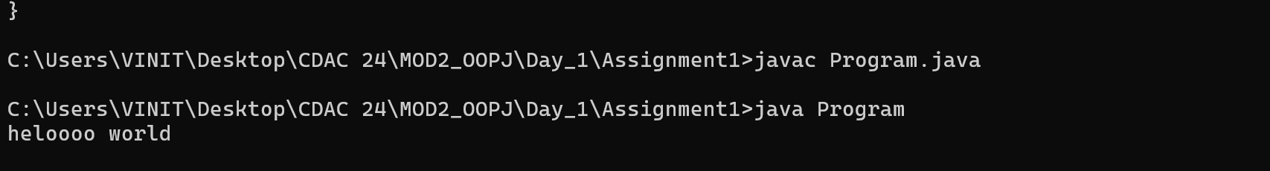

1. **Compile with Verbose Option**: Compile your Java file using the -verbose option with javac. Check the output

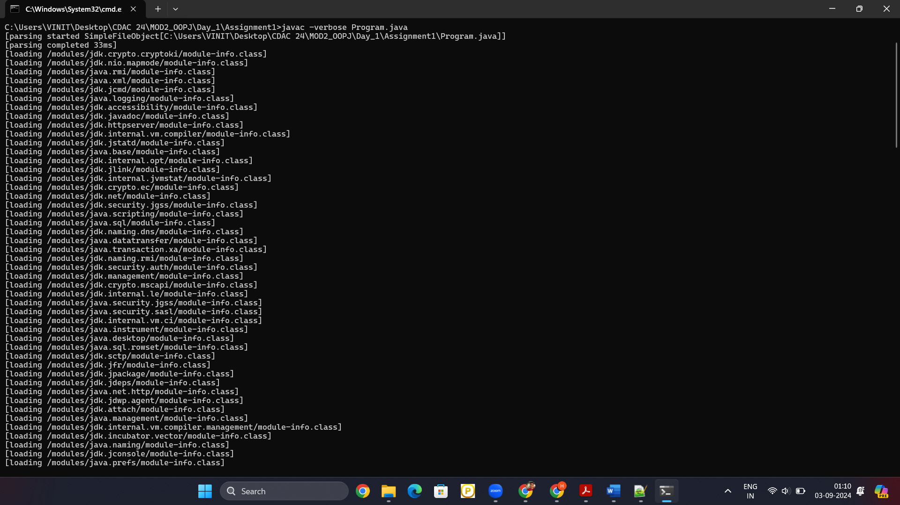

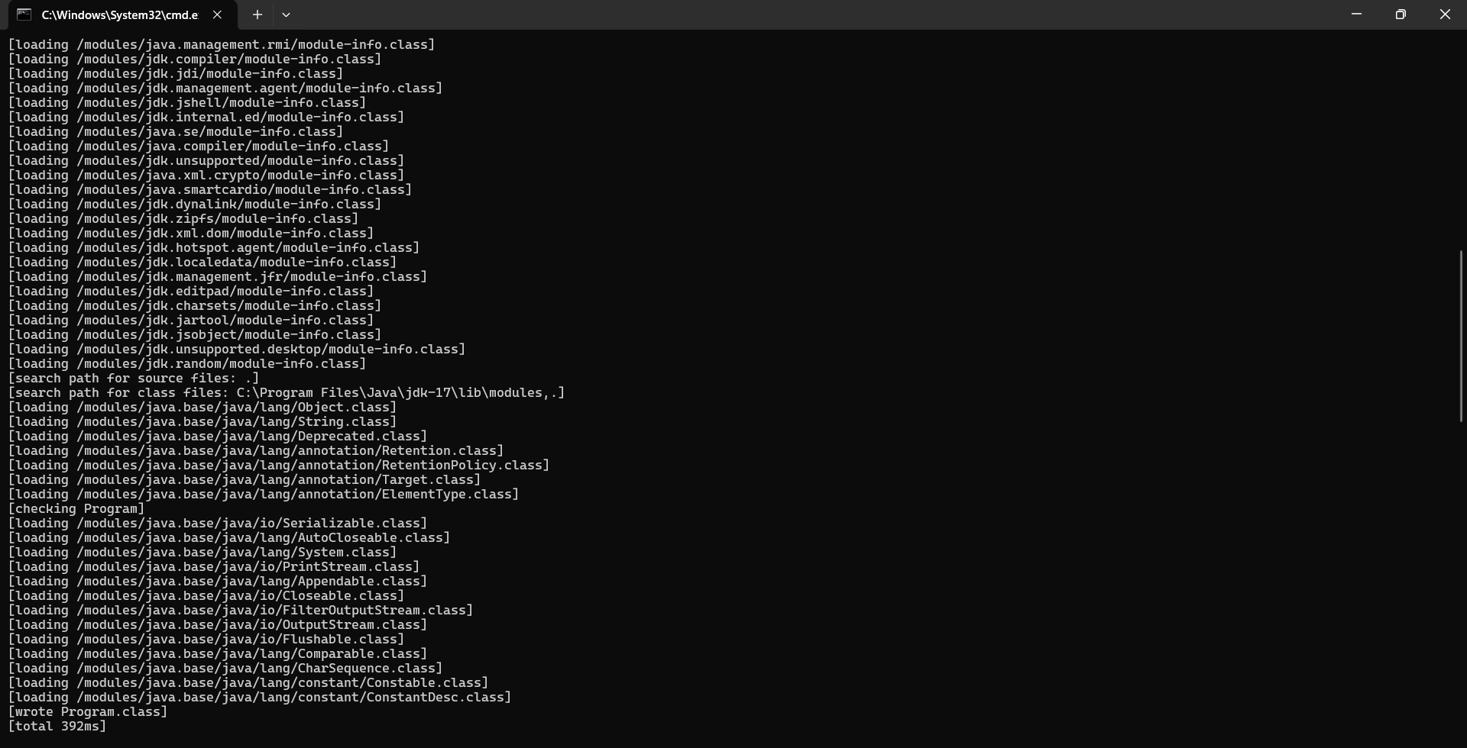

1. **Inspect Bytecode**: Use the javap tool to examine the bytecode of the compiled .class file. Observe the output.

